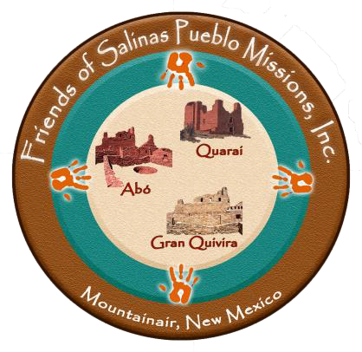

Board Members
Thomas Carroll
Treasurer
Gary Davis Donna C. Deiner

Dianne Doan
Secretary

Kathryn O’Connor Anne Ravenstone
Paul D. Sisson
Vice-Chair
Paula Wells Thomas J. Worker
Chair
The Friends of Salinas Pueblo Missions (FSPM) is an independent non-profit organization dedicated to supporting Salinas Pueblo Missions National Monument (Salinas) in its work of education, interpretation, preservation, protection, and recreation at its four locations.
The goals of the FSPM are:
- to cultivate a general membership of people and organizations eager and willing to help support the work of Salinas;
- to develop projects in cooperation with Salinas staff;
- to raise funds for purposes identified by Salinas staff that are not supported by the NPS budget; and
- to serve as liaison between Salinas, surrounding communities, and partner organizations.

Support what you love and help protect these historic ruins by becoming an FSPM Member today. Your membership contribution directly benefits Salinas Pueblo Missions National Monument and allows FSPM to assist park staff in their year-round management of this archaeological gem, preserving it today and for generations to come. As an FSPM Member, you will receive early notification about park events, invitations to assist with Salinas projects, and the satisfaction of knowing that you are helping to sustain Salinas Pueblo Missions National Monument now and for the future.
All memberships and donations support Salinas Pueblo Missions National Monument (FEIN 82-3490872) and are tax deductible under IRS code 501(c)(3). Please make checks payable to Friends of Salinas Pueblo Missions.
friendsofsalinaspueblomissions@gmail.com Follow us, Like us on Facebook!

friendsofsalinas.org
---------------------------------------------------- Cut Here ---------------------------------
Friends of Salinas Pueblo Missions Membership Form
Please indicate your membership level. Additional donations are welcome and greatly appreciated.
Seniors (62 and over) and Students $12 per year Torrance County Business $50 per year
Individuals $24 per year Statewide Business $100 per year
Family $36 per year National Business $250 per year
____Lifetime $250
Additional Donation (Thank you!) $ Please check if you would like to volunteer to help with events.
Name: Email:
Mailing Address: Phone: Log into your PayPal account to send money to friendsofsalinaspueblomissions@gmail.com,
PO Box 866 email: friendsofsalinaspueblomissions@gmail.com
Mountainair, NM 87036
or send a check to FSPM, PO Box 866, Mountainair, NM 87036. (rev: 10/22)

